EXPERIMENT 01(OBJ-1):-
PROGRAM CODE:-
clc; clear; close all;
fs=1000; t=0:1/fs:1;
TBW=600; Users=3;
CBW=TBW/Users;
fc=[100 300 500];
m=sin(2*pi*10*t);
s1=m.*cos(2*pi*fc(1)*t);
s2=m.*cos(2*pi*fc(2)*t);
s3=m.*cos(2*pi*fc(3)*t);
subplot(2,1,1) plot(t,s1,'r',t,s2,'g',t,s3,'b'),
grid on
title('FDMA Channel Allocation'),
xlabel('Time (s)'),
ylabel('Amplitude') subplot(2,1,2)
bar(1:Users,CBW*ones(1,Users)),
grid on xlabel('Users'),
ylabel('Channel Bandwidth (kHz)'),
title('Channel Bandwidth per User'
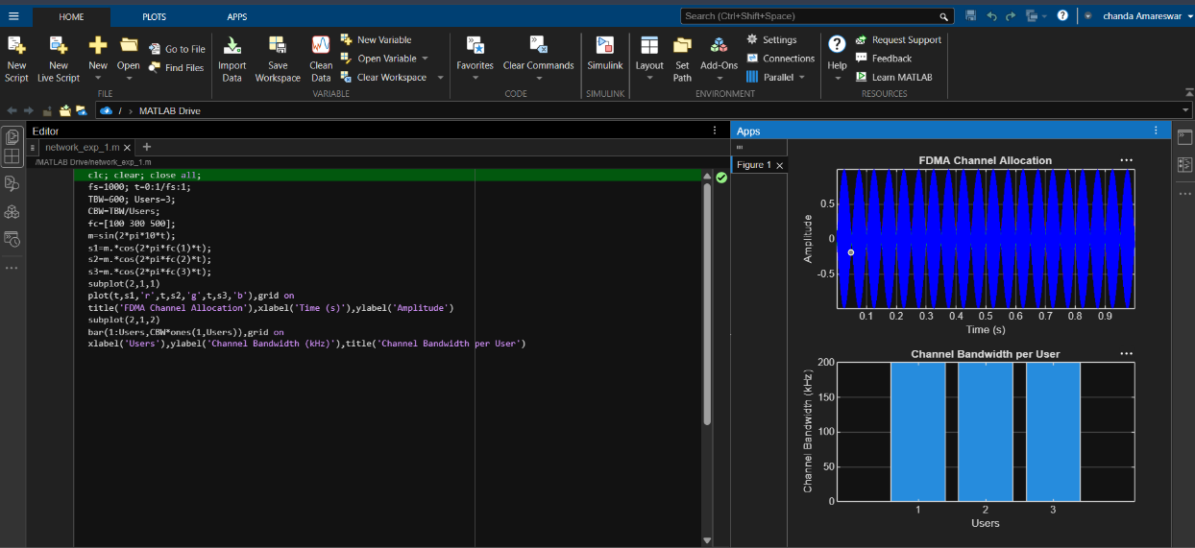
EXPERIMENT 01(OBJ-2):-
PROGRAM CODE:-
clc; clear; close all;
BW = 200;
Users = 3; M = 2; % Channel Bandwidth (kHz) %
BPSK Modulation DataRate = BW*log2(M); % Data Rate (kbps)
Rate = DataRate*ones(1,Users);
disp(' User Data Rate (kbps)')
disp([(1:Users)' Rate'])
figure
bar(1:Users,Rate)
xlabel('Users')
ylabel('Data Rate (kbps)')
title('FDMA Data Rate for Each User')
grid on
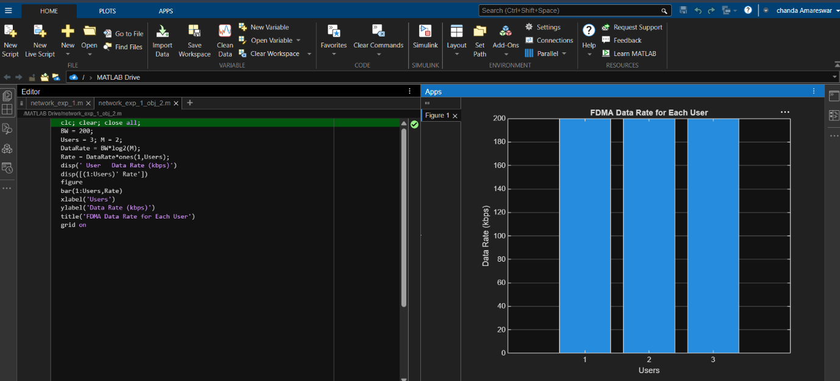

EXPERIMENT 01(OBJ-3):-
PROGRAM CODE:-
clc; clear; close all;
Ps = 1;
Pn = [0.1 0.05 0.01];
Users = 1:3;
SNR = 10*log10(Ps./Pn);
disp('User Noise Power(W) SNR(dB)')
disp([Users' Pn' SNR'])
figure
bar(Users,SNR)
xlabel('Users')
ylabel('SNR (dB)')
title('Signal-to-Noise Ratio of FDMA Users')
grid on
